**www.waynetwplandfill.com**

**Business Tagline or Motto**

**WTL operates a full fleet of tractors, 110 yd**

**walking floor trailers, roll-offs, and various**

**size containers. Our skilled drivers and competent**

**dispatchers are ready to handle your project,**

**with only a phone call or email from you!**

**Serving customers in the waste industry since 1972,**

**the Wayne Township Landfill is a PA DEP permitted**

**municipal/residual waste disposal facility**. **WTL**

**-**

**is not only an environmentally friendly establishment,**

**but we are known for our professionalism and**

**impeccable customer service.**

**Call or**

**email for**

**site specific**

**pricing**

**P.O. BOX 209**

**15**

**LANDFILL LANE**

**MCELHATTAN, PA 17748**

**Phone: 570**

**-**

**769**

**-**

**6977**

**Fax: 570**

**-**

**769**

**-**

**7366**

**www.waynetwplandfill.com**

**Construction & Demolition Waste and Hauling Solutions**

**Wastes accepted:**

•

**DEMOLITION WASTE**

•

**MUNICIPAL WASTE**

•

**RESIDUAL WASTE**

•

**ASBESTOS**

•

**CONTAMINATED SOIL**

•

**WOOD WASTE**

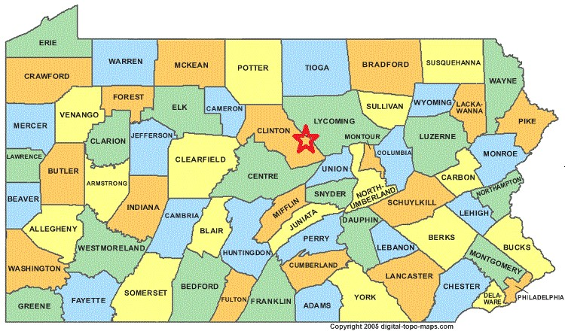

**Conveniently located in Central PA**

**Competitive Statewide**

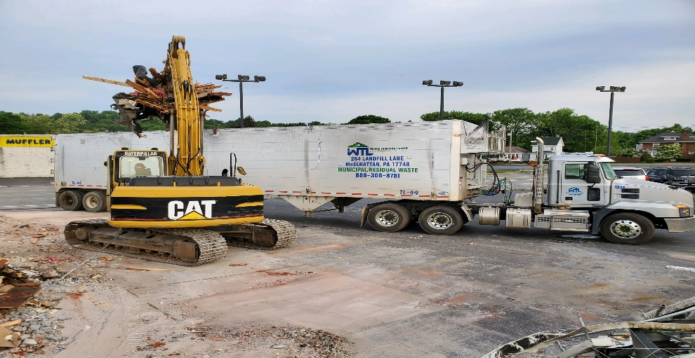

**Lower your projects total cost per ton for hauling and disposal.**

**Call or email today for a**

**quote!**

Tim Givens,

Dispatcher

**570-786-9466, cell**

**570-769-6977, office**

**dispatch@waynetwplandfill.com**

tgivens@waynetwplandfill.com